The Erasmus+ project “The Art of Food” (KA229-4D1A7DD6)
-mobility Sant Pere de Ribes, Spain

The Erasmus+ project “The Art of Food”- mobility C3 took place between 4.11-11.11. 2022 in a small town called Sant Pere de Ribes, not far away from Barcelona, Catalonia, Spain. The Romanian team was represented there by four students and two teachers from “Petru Rares” National College of Suceava.
The first good thing for us in Spain was the perfect sunny weather for this time of the year, although there was cool in the evenings and mornings. Beside this, we also felt the warm welcome of the Spanish teachers, students and their families that made us all feel like home during our stay in Spain.
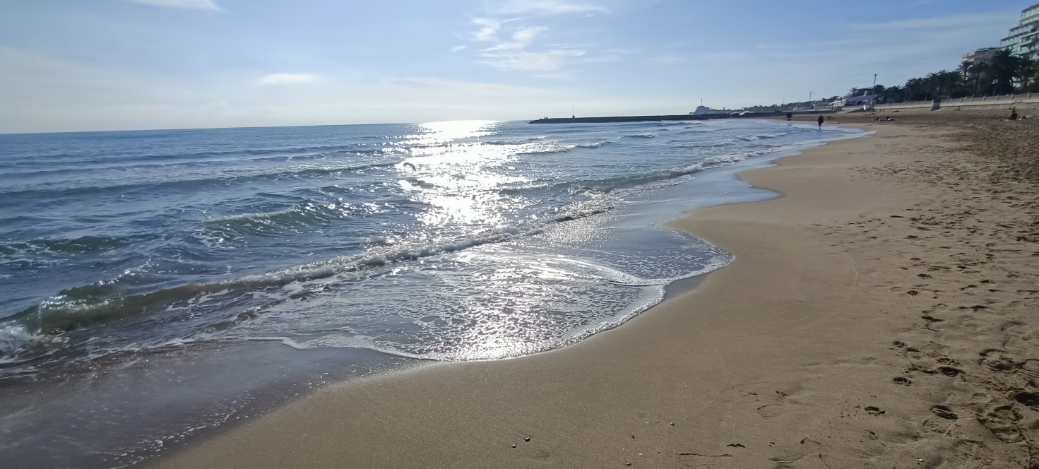
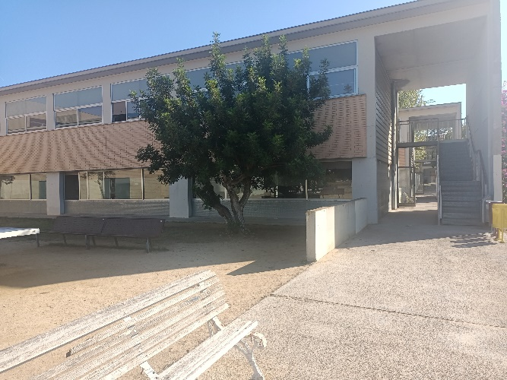
Visiting foreign educational institutions like Institut Can Puig can be extremely beneficial for both students and teachers, thus we visited the school in the first day of the project, finding out many things about the Spanish educational system. Our hosts organised here the majority of the workshops, activities and presentations and we will mention some of the most enjoyable ones.
The first activity to mention was the course in pottery, as ceramics represented the first packaging in the Mediterranean area. The students were taught how to design their own cup on a step-by-step process. Nobody had the prior necessary knowledge about making pottery, but only some clay, a needle tool and good practical advice from a professional instructor who was easy to follow.
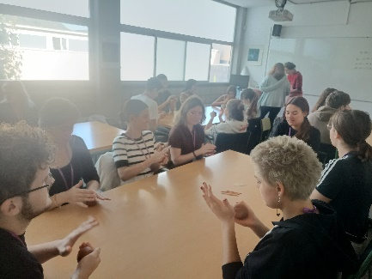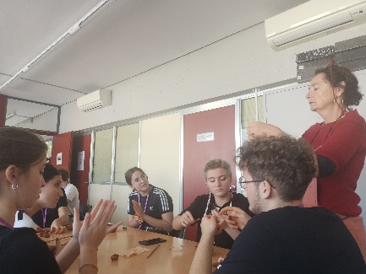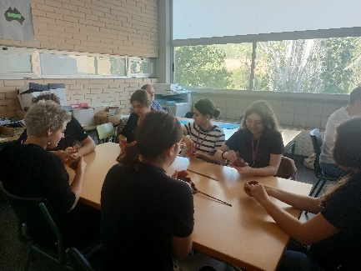
Another interesting workshop was about cardboard packing design, with the expert David Monteagudo. For students, it was the perfect opportunity to learn the basics of packaging and design their own sustainable trendy box for products which were supposed to be sold later in shops. The students had fun working in international groups and managed to design aesthetic eco-friendly boxes as alternative to plastic or expensive materials in packaging.
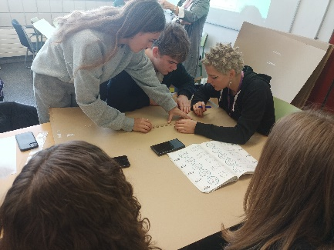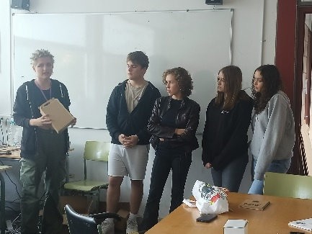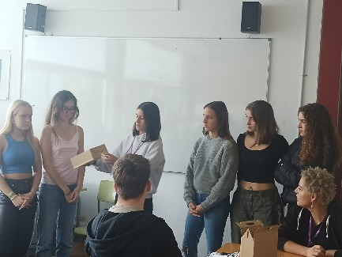
During our stay in Spain, we also had the opportunity to travel and enjoy cultural visits nearby. One day of the project was dedicated to a visit to Sitges, where everybody enjoyed not only the sunny sandy beach but also the historical vineyard of Malvasia de Sitges. (Malvasia Interpretation Centre). The main attraction was the sensory museum, including tasting of products from the winery and snacks (non –alcoholic drinks for students were also available). It was definitely a lovely experience from start to finish and it was worth the trip!
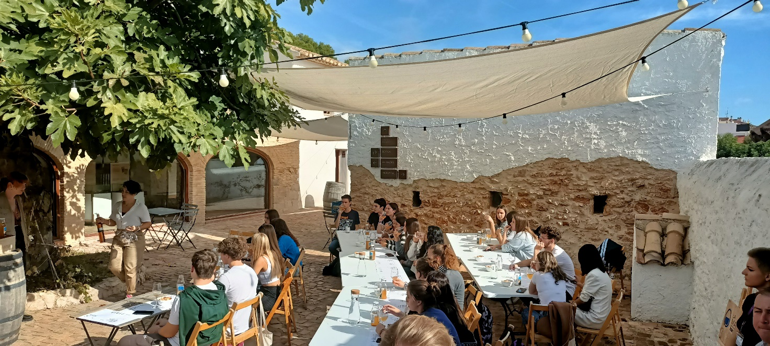
But, of course, the most wanted event was the trip to Barcelona, a place to visit and also to learn about the history and changes of food related concepts in Spain nowadays. Among other places of interest, we stopped by the famous Boqueria (City market) and the port of Barcelona, including the Commercial Port. That one-hour group sail boat tour offered us a unique sail experience, the perfect way to see the city from the sea and the chance to gather information about commerce and business in the area.

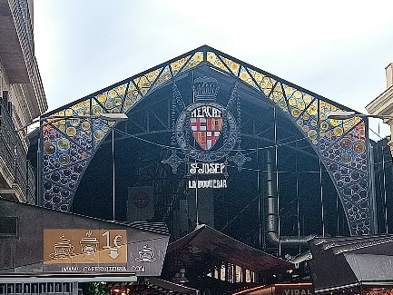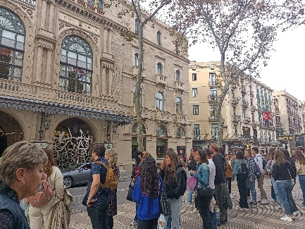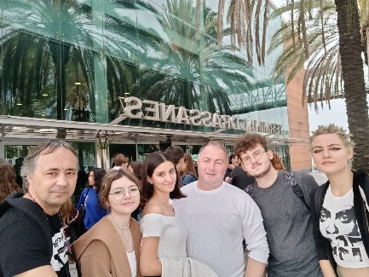
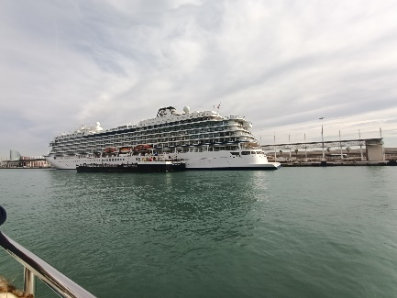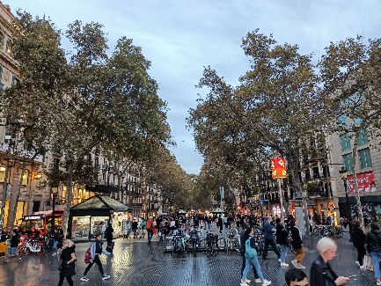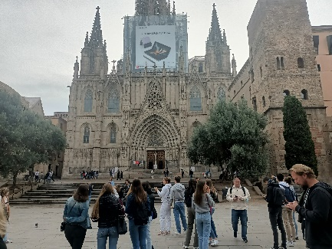

It is difficult to decide on the best moments we had in Spain. Could it be the traditional Spanish dinner all teachers had in a famous local restaurant? Or the final family party, celebrating together the end of the Erasmus meeting? We will definitely never forget this project as we all gathered an amazing array of unforgettable memories.

prof. Cristian SĂLĂGEAN
prof. Marius UDUDEC

